

**Nuclear Instrumentation and Measurement**

**0407204, Fall 2024-25**

**Midterm Exam**

|  |  |
| --- | --- |
| **Instructor:** | **Dr. Muhammad Zubair** |
| **CRN:** | **11582** |
| **Section:** | **11** |
| **Date and Time:** | **October 14, 2024, 2:00– 3:00 PM** |
| **Place:** | **M10-004** |

|  |  |  |  |
| --- | --- | --- | --- |
| Student Name: |  | **ID:** |  |

**Grading**

|  |  |  |  |
| --- | --- | --- | --- |
| **Q1** | **Q2** | **Q3** | **Total** |
| **10** | **10** | **10** | **30** |
|  |  |  |  |

**Useful Data:**

1 amu=1.6605x10-27 kg, 1 amu ≡ 931.48 MeV, 1 eV = 1.6022 × 10-19 J , me = 0.0005486 amu

235U = 235.0439, 117Sn = 116.9029, 118Sn = 117.9016

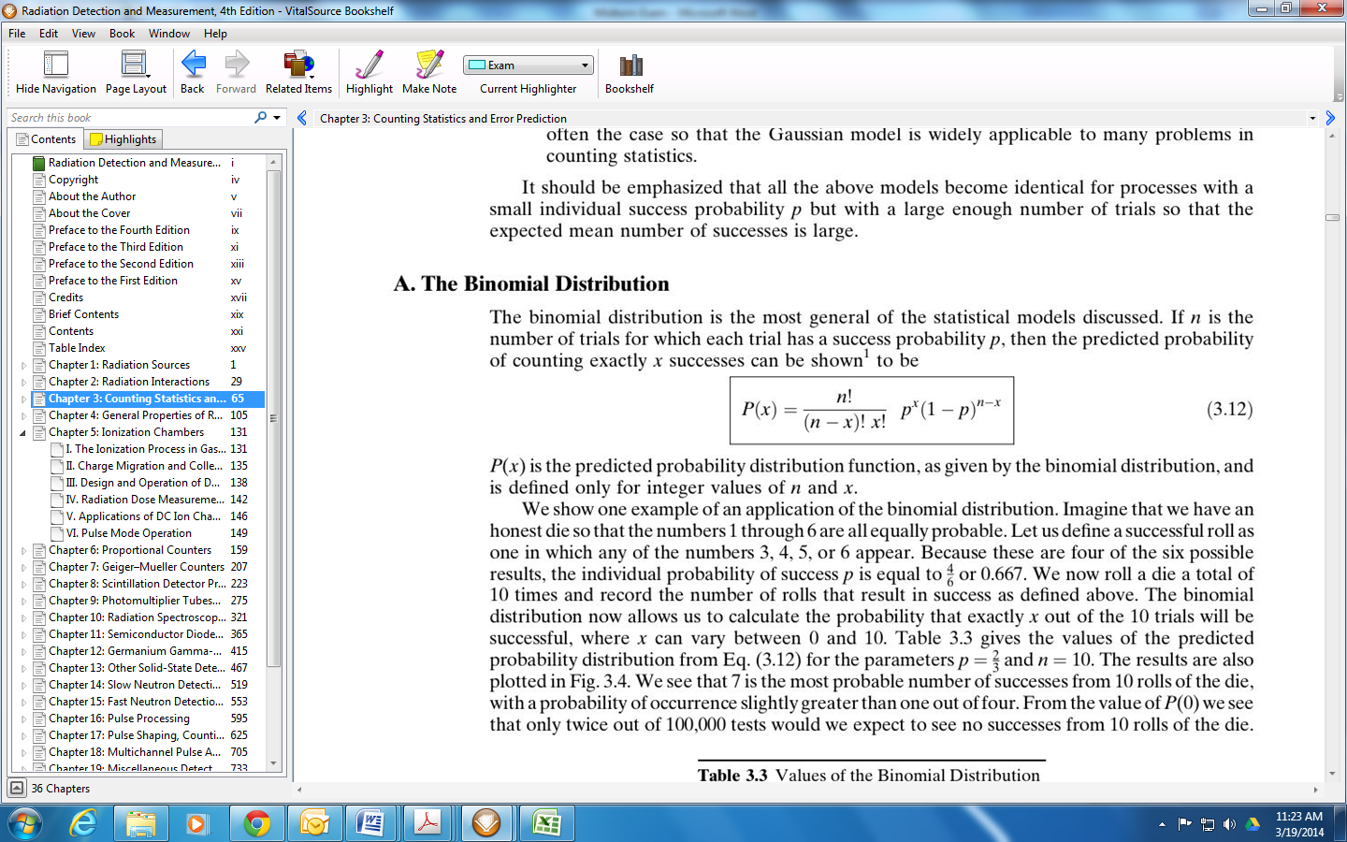

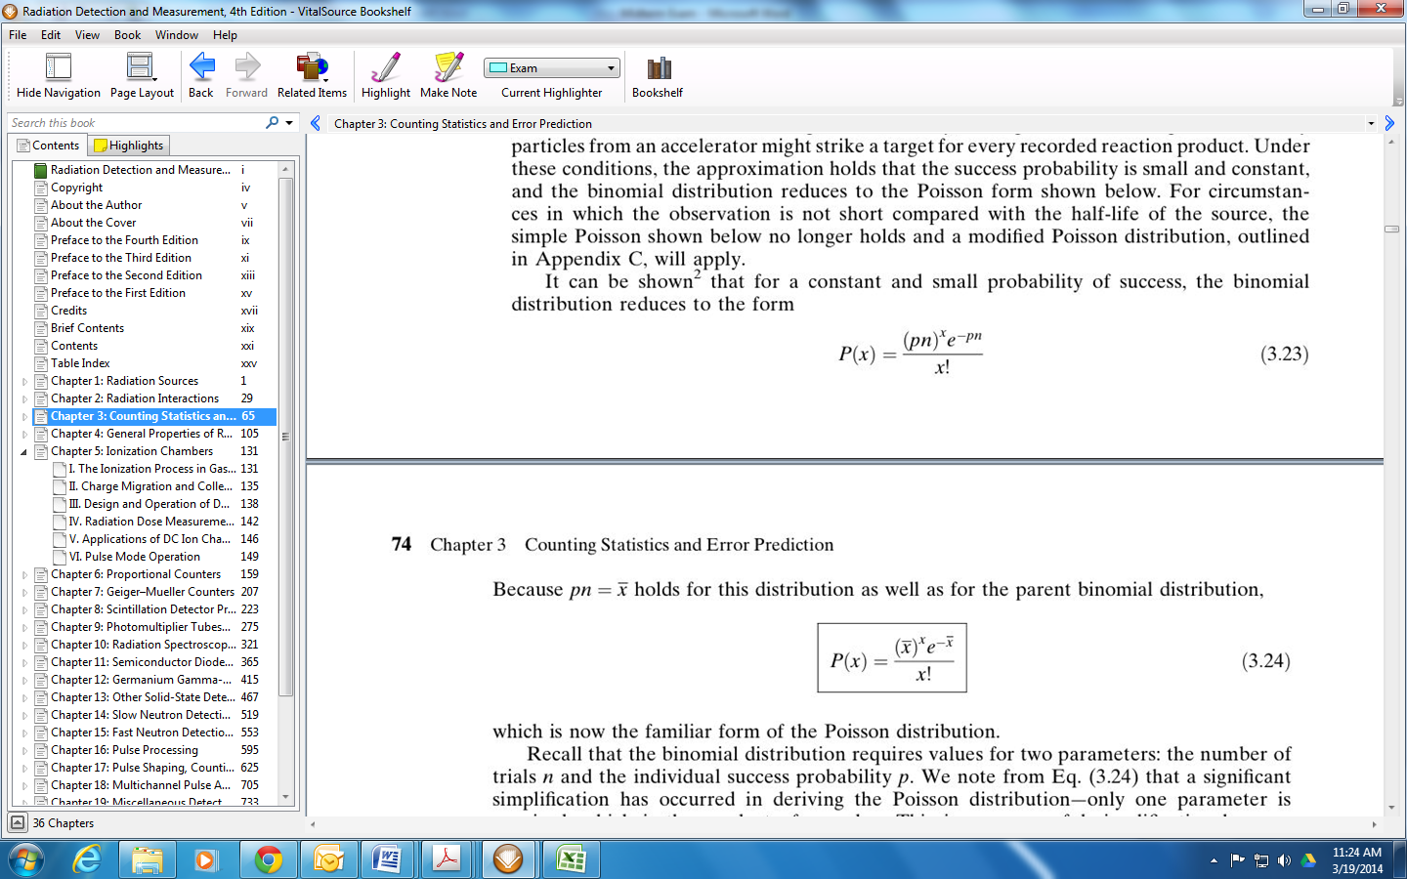



**Answer all of the following questions:**

**Question #1 (5+5 Points):**

1. For each of the radiation sources listed below, indicate whether "discrete" or "continuous" is a better description:
2. Conversion electrons
3. Auger electrons
4. Fission fragments
5. Bremsstrahlung
6. Annihilation radiation

**Discrete: i, ii, v**

**Continuous: iii, iv**

1. Using the reaction below, find the energy released by the spontaneous fission of 235U into two equal-mass fragments.

235U 🡪 117Sn + 118Sn



**Question #2 (5+5):**

1. Calculate the mean free path of 1 MeV gamma rays in sodium iodide (specific gravity= 3.67, and the mass attenuation coefficient is 0.06 cm2/gm).



1. What fraction of 2-MeV betas will go through a single Al (density = 2.7x103 kg/m3) foil of thickness 0.1 mm? Where; μ = 0.7714 m2/Kg



**Question #3 (5+5 points):**

1. A 10-min count of a source+ background gives a total of 846 counts. Background alone counted for 10 min gives a total of 73 counts. What is the net counting rate due to source alone, and what is its associated standard deviation?

1. Explain in your words the term, “Minimum Detectable Activity”.

The minimum detectable activity (MDA) is the smallest net count that can be reported with a certain degree of confidence that represents a true activity from a sample and is not a statistical variation of the background.